Book

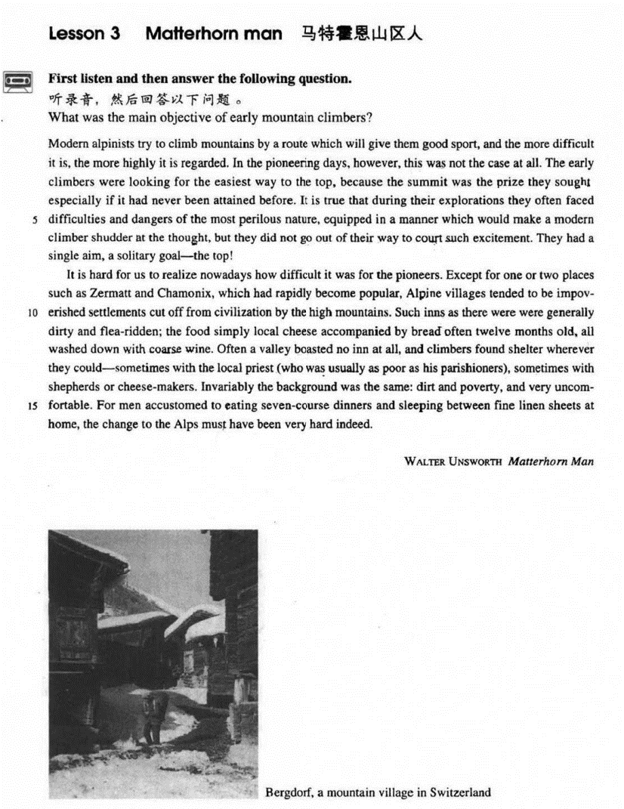

课文

Modern alpinists try to climb mountains by a route which will give them good sport, and the more difficult it is, the more highly it is regarded.

现代登山运动员总想找一条能够给他们带来运动乐趣的路线来攀登山峰，他们认为， 道路愈艰险愈带劲儿。

In the pioneering days, however, this was not the case at all.

然而，在登山运动的初期，全然不是这种情况。

The early climbers were looking for the easiest way to the top because the summit was the prize they sought, especially if it had never been attained before.

早期登山者所寻找的是通往山顶的最方便的途径，因为顶峰特别是前人未曾到过的顶峰 -- 才是他们寻求的目标。

It is true that during their explorations they often faced difficulties and dangers of the most perilous nature, equipped in a manner which would make a modern climber shudder at the thought, but they did not go out of their way to court such excitement.

确实，在探险中他们经常遇到惊心动魄的困难和危险，而他们装备之简陋足以使现代登山者一想起来就胆战心惊，但是他们并非故意寻求这种刺激，

They had a single aim, a solitary goal -- the top!

他们只有一个目标，唯一的目标 -- 顶峰！

It is hard for us to realize nowadays how difficult it was for the pioneers.

我们今天很难想像昔日的登山先驱们是多么艰苦。

Except for one or two places such as Zermatt and Chamonix, which had rapidly become popular, Alpine villages tended to be impoverished settlements cut off from civilization by the high mountains.

除了泽曼特和夏蒙尼等一两个很快出了名的地方外，阿尔卑斯山山区的小村几乎全是高山环抱、与世隔绝的穷乡僻壤。

Such inns as there were were generally dirty and flea-ridden; the food simply local cheese accompanied by bread often 12 months old, all washed down with coarse wine.

那里的小客栈一般都很肮脏，而且跳蚤猖獗；食物是当地的干酪和通常存放了一年之久的面包，人们就着劣酒吞下这种食物。

Often a valley boasted no inn at all, and climbers found shelter wherever they could --sometimes with the local priest (who was usually as poor as his parishioners), sometimes with shepherds or cheese-makers.

山谷里常常没有小客栈，登山者只好随遇而安，有时同当地牧师 （他通常和他的教民一样穷）住在一起，有时同牧羊人或制乳酪的人住在一起。

Invariably the background was the same: dirt and poverty, and very uncomfortable.

无论住在哪儿，情况都一样：肮脏、贫穷，极其不舒适。

For men accustomed to eating seven-course dinners and sleeping between fine linen sheets at home, the change to the Alps must have been very hard indeed.

对于过惯了一顿饭吃7道菜、睡亚麻细布床单的人来说，变换一下生活环境来到阿尔卑斯山山区，那一定是很艰难的。

词汇讲解

### alpinist

* **alpinist** ['ælpɪnɪst] n. （阿尔卑斯山的）登山者

**alpinist** / **Alpinist**

**【近义词组】**

**mountain climber** n.登山者；登山的勇者；骑自行车爬山

**mountaineer** n. 登山家，登山运动员；山地人

**mountain climbing** n. 爬山；登山；攀岩

**mountaineering** n. 登山；登山运动；爬山

**【同根词】**

**alpinism** / **Alpinism** n. 登山

**the Alps** 阿尔卑斯山(脉)

**【扩展】**阿尔卑斯山脉相关：

**Mont Blanc** 白朗峰

**Mont matterhorn** 马特洪峰（阿尔卑斯山峰之一，位于瑞士与意大利之间的边境）

**Chamonix** 夏蒙尼（地名, 法国小镇, 是阿尔卑斯山脉的典型山城）

* the cradle of modern mountaineering；

**Alpine** / **alpine**

* **alpine** villages
* breathtaking **alpine** scenery

### pioneer

* **pioneer** [7paɪə'nɪə(r)] n. 先驱，探索者；v.开拓，探索
* Henry Ford was a **pioneer** in the auto industry.
* The Wright brothers **pioneered** in early aviation.

**【同根词】**

**pioneering** adj. 首创的；先驱的；开拓的

* **pioneering** work
* **pioneering** spirit
* in the **pioneering** days

**【扩展】**表达**“开拓”**：

**break new ground** 打出一片新天地

* His reform programs **broke new ground** in somewhere.

**ground-breaking** adj. 独创的；开拓性的

* **ground-breaking** educational reforms

**lead the way** 领路

* The company has **led the way** in developing environment-friendly products.

### summit

* **summit** ['sʌmɪt] n. 山顶，顶点；峰会

**summit** / **peak**

* the **summit** / **peak** of his career
* The two presidents agreed to hold a **summit** in the coming spring.
* They hope to finish in time for a trade **summit** between America and the EU on May 28th.

**【近义词】【扩展】**表达**“**峰**”**：

**crest** n. [物] 波峰；冠；山顶；顶饰

**pinnacle** n. 高峰；小尖塔；尖峰；极点

* the **crest**/**pinnacle** of one’s career

**apex** n. 顶点；尖端

* the **apex** of a triangle
* the **apex** of one’s career

**zenith** n. 顶峰；顶点；最高点

* At the **zenith** of its power, the Yuan Dynasty ruled almost all of the Eurasian continent.

### perilous

* **perilous** ['perələs] adj. 非常危险的
* a **perilous** journey across the mountains
* **perilous** country roads

**【同根词】**

**peril** n. 危险；冒险；vt. 危及；置…于险境

* The ship was in grave **peril**.

**【近义词】****【扩展】**

**hazardous** adj. 有危险的；冒险的；碰运气的

* a **hazardous** investment
* Being the President’s bodyguard is a **hazardous** occupation.

**hazard** n. 危险，冒险；冒险的事；vt. 赌运气；冒…的危险，使遭受危险

* a health（健康） / safety（安全） / fire（火灾） / traffic（交通） **hazard** …隐患

**be / present / pose / constitute a hazard to …** 对于…构成隐患

* The busy traffic entrance is / presents / poses / constitutes a **hazard** to pedestrians.
* Our knowledge of the oceans a hundred years ago was confined to the two-dimensional shape of the sea surface and the **hazards** of navigation **presented** by the irregularities in depth of the shallow water close to the land.

**be / present / pose / constitute a threat / menace to …** 构成威胁

* Inflation may **pose a** potential **threat to** China’s social stability.
* Religious extremism **constitutes a** grave **menace to** the security and stability in the region.

### shudder

* **shudder** ['ʃʌdə(r)]v. 颤抖，不寒而栗
* She **shuddered** at the thought of the murder.
* The ship **shuddered** when she struck the rocks.

**【近义词】**表达“颤抖”：

**tremble**

**shiver**

**quiver**

* Suddenly, there was a slight **trembling** sound from below, and the captain went down to see what had happened.
* He **trembled *with*** *anger / fear / excitement*.
* When I kiss your lips, ooh I start to **shiver**, Can’t control the **quivering** inside. Wouldn’t you agree, baby you and me got a groovy kind of love.

### court

* **court** [kɔ:rt] v. 追求

**【含义1】**表达“**n. 朝廷**”：

* A friend in **court**（n. 朝廷） is better than a penny in purse.

**courtesy** n. 礼貌；好意；恩惠

**courteous** adj. 有礼貌的；谦恭的

**【含义2】**表达“**n. 法庭**”：

**go to court** 打官司

**settle sth. out of court** 私了

**【含义3】**表达“**n. （中型）比赛场地**”：

a tennis / basketball **court**

**【含义4】**表达“**v.讨好**”：

* Some businessmen **court** only wealthy clients.

**【含义4】**表达“**v.追求**”：

* John has been **courting** Mary for 3 years.
* **court** fame and gain 追名逐利

**【含义5】**表达“**v.导致**”：

* Pride **courts** failure.

### solitary

* **solitary** ['sɒlətri] adj. 唯一的
* Beckham scored the **solitary** goal of the game.
* They had a single aim, a **solitary** goal—top!

**【同根词】**

**solitude** n.独处（未必感到孤独）

**【辨析】**

**loneliness** n. 寂寞，孤独

* Perhaps it is the desire for **solitude** or the chance of making an unexpected discovery that lures people down to the depths of the earth.
* I love tranquil **solitude**. —— P. B. Shelley

**in solitude** 独处中

* I spent the morning **in solitude**.
* I live **in** that **solitude** which is painful in youth, but delicious in the years of maturity. —— Albert Einstein

**【词根】**

“**sol** ” = alone

**sole** adj. 唯一的；单独的；仅有的

**solo** n. 独奏；独唱；独奏曲

**soliloquy** n. 独白；自言自语

### impoverish

* **impoverish** [ɪm'pɒvərɪʃ] v. 使贫困
* The EU trade policies will **impoverish** developing countries.

**【扩展】**

**deplete** vt. 耗尽，用尽；使衰竭，使空虚

* Solar storms **deplete** ozone layer.

**impoverished** adj. 穷困的；用尽了的，无创造性的

**destitute** adj. 穷困的；无的；缺乏的

* the institute for the **destitute**

**【近义词】**表达“贫穷”：

**deprived**

**disadvantaged**

**underprivileged**

* **underdeveloped** countries / regions …

### flea-ridden

* **flea-ridden** [fli: 'rɪdn] adj. 布满跳蚤的

**flea** n. 跳蚤

**【辨析】**

**flee** (fled, fled)

* When Mrs. Richards walked towards him, he **fled**, slamming the door behind him.

**【词根】**

“**-ridden**”: full of sth. unpleasant 充满了令人讨厌的东西

* **debt-ridden** countries
* **mosquito-ridden** swamps
* **disease-ridden** slums

**【词根】【扩展】**

“*-***infested**” 充满了令人讨厌的东西

* **shark-infested** waters
* **rat-infested** warehouses
* **insect-infested** trees

### boast

* **boast** [bəʊst] v. 炫耀，自夸**（人做主语）**；拥有**（物做主语）**

**boast of / about sth.** 炫耀…

**boast that …** 炫耀…

* Every salesman **boasts of** his own wares. 炫耀，自夸**（人做主语）**
* Bush **boasted that** the world was safer with Saddam hanged. 炫耀，自夸**（人做主语）**
* China and France **boast** sound bilateral relations. 拥有**（物做主语）**
* China and the EU **boast** consensus on environment. 拥有**（物做主语）**

**【扩展】**表达“**拥有**”：

**enjoy**

* The city at one time must have been prosperous, for it **enjoyed** a high level of civilization.

**be blessed with …** 享有

* They **were blessed with** two children, a boy and a girl.

**be endowed with …** （天生）拥有

* She **is endowed with** both brains and beauty.
* **Declaration of Independence** 独立宣言
* **We hold these truths to be self-evident, that all men are created equal, that they are endowed by the Creator with certain unalienable rights, that among these are life, liberty, and the pursuit of happiness. ― Thomas Jefferson**

**cherish** 怀有（感情等）；抱有（希望等）

* Like a scientist bent on making a discovery, he must **cherish** the hope that one day he will be amply rewarded.
* He **cherished** the memory of his late wife.

**be free from …** 没有某个不好的东西

* The composition **is free from errors**.
* Organic produce **is free from** harmful chemicals.
* He may never be sure where the next meal is coming from, but he **is free from** the thousands of anxieties which afflict other people.

### parishioner

* **parishioner** [pə'rɪʃənə(r)] n. 教区居民

**【相关词组】**

**parishioner** n. 教区居民

**parish** n. 教区

**church** n. 教堂

**diocese** n. 主教教区

**cathedral** n. 大教堂

课文讲解

# （标题）

# Matterhorn man

知识点（1）

**写作**：alliteration头韵

* **F**inding **f**ossil man (Lesson1)
* **Sp**are that **sp**ider (Lesson2)
* **M**atterhorn **m**an (Lesson3)
* The **sp**orting **sp**irit (Lesson6)
* **Pr**ide and **Pr**ejudice (傲慢与偏见)
* **P**rince and **P**auper (王子与乞丐)
* **W**orld **W**ide **W**atch (世界观察)
* A **D**elicious **D**ish A **D**ay （甜甜饮食）
* **B**eauty and **B**east （美女与野兽）

# （第一段）

# Modern alpinists try to climb mountains by a route which will give them good sport, and the more difficult it is, the more highly it is regarded.

**语法分析：**

Modern alpinists try to climb mountains by a route **which** will give them good sport, and *the more difficult it is（比较状语从句）*, the more highly it is regarded. （**which**...定语从句）

知识点（1）

**【近似词组】**表达“**当代的**”：

**modern**

**modern-day**

**present-day today’s …**

**… of today**

**contemporary**

知识点（2）

**sport** n. [U] fun; amusement 乐趣

* Swimming in the sea will give you good **sport**.
* He tormented the cat only **for sport**.（找乐趣）
* On the occasions when they have pushed to shore an unconscious human being they have much more likely done it out of curiosity or **for sport**, as in riding the bow waves of a ship.
* **课文写法替换：**
* …which will give them **good sport**, …
* …which will give them **good / a lot of fun**, …

**【辨析】sport**

***a* good sport** 输得起的人

* Hey, man! Be **a good sport**!

**a bad / poor sport** 输不起的人

**a sore loser** 输不起的人

知识点（3）Lesson03-09、Lesson 03-43、Lesson 03-55 比较级（10）

**语法**：“**越…越…**”比较

**1）.两个the 分别放在句首，前半句从句，后半句是主句，从前往后翻译**

* The harder they worked(前半句从句，类似条件状语从句) the hungrier they became. （后半句是主句）
* The more he gets, the more he wants
* The harder you work, the greater progress you will（时态：主将从现） make.
* It seems that the further cats fall, the less they are likely to injure themselves.
* **主句倒装**
* The younger the child is （从句）, the more *is* the child’s need of sleep. （主句，倒装）
* The more democracy spreads, the stronger *become*（倒装）the forces of peace.
* **如果谓语动词是be动词，这种句型可省略:**
* The younger the child *is*, the more *is / will be* the child’s need of sleep.
* The younger the child, the more the child’s need of sleep. （be动词省略）
* The higher the standard of living, the greater the amount of paper used. （be动词省略）
* The higher the standard of living *is*, the greater *is / will be*（倒装）the amount of paper used.
* The stronger the magnet, the greater the number of lines of magnetic force. （be动词省略）
* The stronger the magnet *is*, the greater *is* （倒装）the number of lines of magnetic force.
* The greater the percentage of such customers, the weaker the argument’s evidence as an indication of customer satisfaction with the change.
* The greater the percentage of such customers is, the weaker is the argument’s evidence as an indication of customer satisfaction with the change.
* **课文写法替换：**Lesson03-44
* Needless to say, the bigger the risk an insurance company takes, the higher the premium you will have to pay.
* Needless to say, the bigger the risk an insurance company takes *is,* the higher *will be*（倒装）the premium you will have to pay.

**2）.第一句the加比较级放在句中，第二句the加比较级放在句首，只能先翻译后半句，再翻译前半句**

* They became (the) hungrier （前半句是主句）the harder they worked.（后半句是从句）
* I play (the) better（主句）, the more（从句） I practice.
* The more（从句） I practice, the better（主句） I play.
* A compound is considered the more stable（主句）, the smaller（从句） its potential energy.
* We are so familiar with the fact that man ages, that people have for years assumed that the process of losing vigour with time, of becoming more likely to die（主句） the older we get（从句）, was something self-evident, like the cooling of a hot kettle or the wearing-out of a pair of shoes.
* A telescope would have to be as far away as the planet Jupiter to look for life in outer space, because the dust becomes thinner（主句） the further we travel（从句） towards the outer edges of our own solar system.

# In the pioneering days, however, this was not the case at all.

知识点（1）Lesson03-22、Lesson03-30

**case** 真实的情况

* One would expect them to know their parts by heart and never have cause to falter. Yet **this is not always the case**.
* No one suspected that there might be someone else on the farm who had never been seen. This was indeed **the case**.

表达**“实情”**句型：

* Yet this is not always the case. 这**不总**是实情
* **This is not always the case.**  这**不总**是实情
* **This is indeed the case.** 这**的确**是实情
* **This is not the case at all.**  这**完全**不是实情
* **This might not be the case.** 这**可能**不是实情
* **This is not necessarily the case.** 这**不一定**是实情

# The early climbers were looking for the easiest way to the top, because the summit was the prize they sought, especially if it had never been attained before.

**语法分析：**

The early climbers were looking for the easiest way to the top, **because** the summit was the prize they sought（定语从句）, *especially if it had never been attained before**（if... 条件状语从句）.* （**because**... 原因状语从句）

知识点（1）

**The early climbers**

* **课文写法替换：**
* the **pioneers**
* the **pioneer** climbers
* their **predecessors**
* Sometimes we go upstream to a favorite backwater, sometimes we have our party at the boathouse, which a **predecessor** of ours at the farm built in the meadow hard by the deepest pool for swimming and diving.

知识点（2）

**prize** （暗喻）sense of pride / honor / accomplishment 自豪感、荣誉感、成就感

* I came, I saw, I conquered! ——Julius Caesar
* Veni, vidi, vici.

知识点（3）

**seek** v. try to achieve sth. 寻求；寻找；探索；搜索

* **seek** refuge / asylum
* **seek** compensation
* **seek** advice
* The incumbent president will not **seek** reelection.
* Virgo woman **seeks** Scorpio man

# It is true that during their explorations they often faced difficulties and dangers of the most perilous nature, equipped in a manner which would make a modern climber shudder at the thought, but they did not go out of their way to court such excitement.

**语法分析：**

it（形式主语） is true that（that...主语从句） during their explorations they often faced difficulties and dangers of the most perilous nature, ***equipped*** *in a manner which would make a modern climber shudder* ***at the thought******（at…时间状语）****（which...定语从句，修饰manner）****（equipped... 方式状语）****,* but they did not go out of their way to court such excitement.

知识点（1）Lesson03-16、Lesson03-43

**It is true that ..., but ...**诚然…但… (先让步，再转折)（让步转折结构）

* **It was true that** he had just bought a lamb, he explained, **but** his lamb was black.
* **造句**：诚然中国还是一个发展中国家，但是她却充满了潜力。
* **It is true that** China is still a developing country, **but** she is full of potential.

* **It is true that**during their explorations they often faced difficulties and dangers of the most perilous nature, equipped in a manner which would make a modern climber shudder at the thought, **but** they did not go out of their way to court such excitement.

**【近似词组】**表达“**诚然…但… (先让步，再转折)**”：

**It is true that ..., but ...**

**Admittedly, ..., but ...**

**Granted, …, but …**

* **Admittedly**, I could have tried harder, **but** I still don't think all this criticism is fair.
* **Granted**, he doesn't look too bad for his age, **but** I don't fancy him.
* **Granted**, a snobbery of camping itself, based upon equipment and techniques, already exists; **but** it is of a kind that, if he meets it, he can readily understand and deal with.

**让步之后，but/yet后的表达：**

It is true that / Admittedly, / Granted, ...,

**but**/ **yet that is not to say that ...**这并不少说

**but**/ **yet it does not follow that ...**这不一定得出这样的结论

**but**/ **yet it does not necessarily mean that ...**这不对意味着

**but**/ **yet** **we cannot ensure / guarantee that …** 不能保证…

**but**/ **yet there is no guarantee that …**不能保证

知识点（2）

**face**/**confront** 面临着

**be faced** (强调动态) **/ confronted** (强调状态) **with …** 面临着…

* China **is faced / confronted with** the problem of overpopulation.
* **6级阅读：**
* But if the animals **are confronted with** situations they have no control over, they later behave passively when **faced with** experiences they can control.

知识点（3）

**语法：of a … nature** 做后置定语，修饰前面的名词；表示“某种类型的…”

* … dangers ***of*** the most perilous **nature** …
* I can’t approve of things ***of***this **nature**. 这种事
* treaties ***of***a political nature 政治性的条约
* books ***of***an erotic nature 色情的书刊
* questions ***of***an academic **nature** 学术性的问题
* articles ***of***a technical nature 技术性的文章

知识点（4）Lesson03-03

**be equipped with …** 装备上…

* The city **was** even **equipped with** a drainage system, for a great many clay pipes were found beneath the narrow streets.

知识点（5）

**in a manner** 以…方式；manner单数

知识点（6）Lesson03-23

**at the thought of** 一想到

* **at the thought of** *the manner*

**at the … of …** 【时间状语短语】一…就

* On the other hand, your stomach would turn **at the idea of** frying potatoes in animal fat -- the normally accepted practice in many northern countries.
* Most of my friends live in the city, yet they always go into raptures **at the mere mention of** the country.
* She screamed **at the** **sight** **of** the ghost. 一看到就…
* She trembled **at the thought of** the murder. 一想到就…
* She fainted **at the news of** her father’s death. 一 获得（消息）就…
* She wept **at the mention of** the accident.一提到就…

【课文仿写】

* 造句: 防暴警察(riot police)在体育场外巡逻(patrol the stadium)，装备得使足球流氓(soccer hooligan)一看到就不寒而栗。
* Riot police were patrolling the stadium, equipped in a manner which would make a soccer hooligan shudder at the sight.

知识点（7）

**go out of one’s way (to do …)** 不怕麻烦的特意做某事

* Please **don’t go out of your way** for me.
* It was very kind of you to **go out of your way to meet** us at the airport.

# They had a single aim, a solitary goal -- the top!

知识点（1）

… a single aim, a solitary goal …

**写作**：同义词连用；加强语气

* **中文举例：**
* 虚情假意
* 山盟海誓
* 千刀万剐
* 深仇大恨
* **英文举例：**
* I’m **sick and tired** of your silliness. 形容词
* He is never one to **pick and choose**.动词
* She is always complaining of her **aches and pains**.名词

# （第二段）

# It is hard for us to realize nowadays how difficult it was for the pioneers.

**语法分析：**

it（形式主语） is hard *for us（for … 引出动词不定式的逻辑主语）* to realize nowadays（时间状语） how difficult it was for the pioneers（how… 宾语从句）. （to … 真正主语）

# Except for one or two places such as Zermatt and Chamonix, which had rapidly become popular, Alpine villages tended to be impoverished settlements cut off from civilization by the high mountains.

**语法分析：**

*Except for one or two places such as Zermatt and Chamonix, which had rapidly become popular* *（which...定语从句）（such as ...同位语）*（*Except for …* 介词短语做状语）, Alpine villages tended to be impoverished settlements cut off from civilization by the high mountains. （cut off… 非谓语动词引导原因状语）

知识点（1）

**except for / but for … 含义1：**除了……（放在句首，要带上for）

**except for / but for / if it were not for … 含义2：**若没有……的话（虚拟语气）

* **except for** / **but for** / **if it were not for** your support, I **would**（虚拟语气） be in big trouble now.
* Insects **would**（虚拟语气） make it impossible for us to live in the world; they **would**（虚拟语气） devour all our crops and kill our flocks and herds, **if it were not for** the protection we get from insect-eating animals.

**except / but (that) …含义1：**除了…… **含义2：**若没有……的话

* I would buy a Mercedes **except** / **but (that)** I ***am***（真实情况） poor.
* I would buy a Mercedes if I ***were***（虚拟情况） rich.

知识点（2）地点介绍

Zermatt

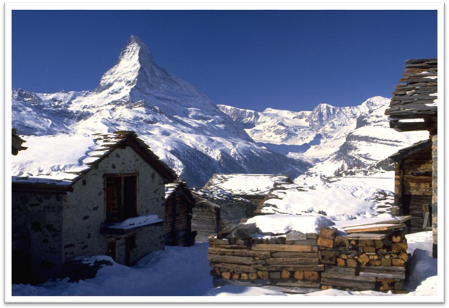

Chamonix: the cradle of modern mountaineering

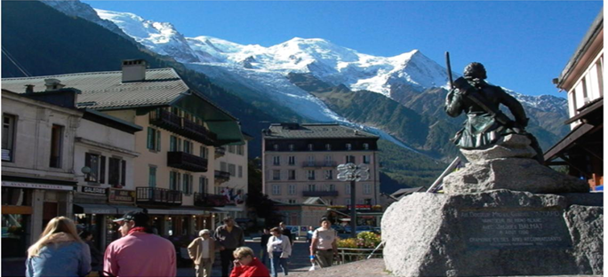

知识点（3）

**tend to do** 往往

* People **tend to** need less sleep when they get older.
* Women **tend to** live longer than men.

**【近似词组】**表达“**往往、常常、多数情况下**”：

**have a tendency to do**

* The drug is effective but **has a tendency** to cause headaches.

**generally**

**In general**

**mostly**

**in most cases**

**on the whole**

**by and large**

**for the most part**

**most of the time**

知识点（4）

settlements 小的居民区、村庄

知识点（5）

* …cut off from civilization by the high mountains. （cut off… 非谓语动词引导原因状语）
* **课文写法替换：**（which were定语从句）（去掉which were就做非谓语）
* … (which were) **cut off from** civilization
* … (which were) **out of touch with** civilization
* … (which were) **isolated from** civilization
* … (which were) **separated from** civilization

# Such inns as there were were generally dirty and flea-ridden; the food simply local cheese accompanied by bread often 12 months old, all washed down with coarse wine.

**语法分析：**

Such inns as there were（限定性定语从句，修饰先行词inns，用as和such固定搭配） were generally dirty and flea-ridden; the food simply local cheese accompanied by bread often twelve months old（非谓语动词做后置定语,修饰cheese；或可以看做伴随状语）, *all（非谓语washed动词的逻辑主语） washed down with coarse wine*.（独立主格）

知识点（1）

**Inn** 乡下的小酒馆

知识点（2）定语从句

**语法**：**限定性定语从句**；先行词如出现such / the same / as / so 后面的关系代词用as，不用which和that

**such / the same / as / so … as …**

* I need ***the same***tool **as** you are using.
* I need ***such***a tool **as** you are using.
* I need ***as***useful a tool **as** you are using.

知识点（3）

* **课文写法替换：**
* Such inns as there were **tended to be**dirty and flea-ridden; …

知识点（4）Lesson04-02

**语法**：并列句中谓语动词课省略

* …; the food *(****was****)* simply local cheese accompanied by bread often 12 months old.
* …, for a spider always has eight legs and insect never (***has***) more than six.
* 非并列句不可省略：
* Paul likes poetry, and Peter *(****likes****)* fiction.
* Paul likes poetry, and I know that Peter *likes（不可省略）* fiction.

知识点（5）

**accompany** 陪伴、伴随

* The disease **is accompanied by** sneezing and fever.

知识点（6）

**wash sth. down with sth.** 用（后者）把（前者）送下去

* We ate some sausage, and **washed** it **down with** whiskey.

# Often a valley boasted no inn at all, and climbers found shelter wherever they could --sometimes with the local priest (who was usually as poor as his parishioners), sometimes with shepherds or cheese-makers.

**语法分析：**

Often a valley **boasted**（事物做主语，表示“有”） no inn at all, and climbers found shelter wherever they could（地点状语）—***sometimes*** *with the local priest (who was usually as poor as* *his parishioners（插入语、定语从句）),* ***sometimes*** *with shepherds or cheese-makers.* （两个*sometimes* 都可以看做wherever they could的同位语）

知识点（1）

**boast** 1.事物做主语，及物；表示“有”；2. 人做主语，不及物；表示“吹嘘”

**【形近词组】**复习

find one’s way 1. 人做主语；表示“找到道路” ；2. 事物做主语；表示“到达某地”

* Specially-made lanterns are hung outside each house to help the dead to **find their way**（人做主语）.
* My nephew, George, has a money box but it is always empty. Very few of the fifty pence pieces and pound coins I have given him have **found their way**（事物做主语） there.

**【形近词组】**Lesson03-40、03-47

**threaten to do**1.（人做主语）威胁做某事；2. （物做主语）有…的威胁

* They **threatened to**（人做主语，威胁做某事） kill him if he didn’t obey.
* Mining operations **threaten to**（物做主语，威胁做某事）destroy our environment.
* We keep trying all four methods, but the sheer volume of rubbish we produce worldwide **threatens to**overwhelm （物做主语，有……的危险）us.

**【形近词组】**

**promise to do** 1.（人做主语）承诺做某事；2. （物做主语）有…的可能

* He **promised to**（人做主语）call me every week.
* It **promises to**（物做主语） be warm today.
* Groundbreaking research by two French geophysicists **promises to**（物做主语） shed some light on the mystery.

知识点（2）

**shelter** 表“住处”时不可数

* Food, clothing, **shelter** and transportation are basic necessities of daily life.

# Invariably the background was the same: dirt and poverty, and very uncomfortable.

**语法分析：**

**Invariably**（=always，放在句首加强语气） the background was the same: **dirt**（同位语） and **poverty**（同位语）, and very uncomfortable（形容词做同位语）.

# For men accustomed to eating seven-course dinners and sleeping between fine linen sheets at home, the change to the Alps must have been very hard indeed.

**语法分析：**

*For men accustomed to (非谓语动词做后置定语) eating seven-course dinners and sleeping between fine linen sheets at home（For... 介词短语做状语）*, the change *to the Alps**（后置定语）* must have been very hard indeed.

知识点（1）

* **形近**：Lesson04-21
* Men *accustomed to struggling for survival against the elements and Indians* were bewildered by politicians, bankers and businessmen, and unhorsed by fences, laws and alien taboos.

**be accustomed to sth. /doing** 习惯于…

= **be used to sth. / doing**

= **be in the habit of sth. / doing**